Architecture Decision Records
Architecture, Data and System Design

Purpose. This document explains the architecture, implementation decisions, data model, workflow state machine, role and permission boundaries, audit strategy, document versioning, frontend/backend integration, and run instructions for the BNR Licensing & Compliance Portal. It is written as an Architecture Decision Record package because the assessment emphasizes reasoning, trade-offs, and senior-level judgment, not only feature completion.

1. Problem Understanding and Design Goals
BNR licensing is a high-stakes regulatory workflow. The legacy process described in the challenge is manual: applications arrive by email, documents are tracked in spreadsheets, and approvals move through informal channels. The proposed system creates a controlled digital workflow with a single source of truth, consistent state transitions, immutable audit evidence, and backend-enforced authorization.

Primary design goals
- Correctness over feature volume: the most important requirement is not a lot of services and screens, but reliable enforcement of workflow and security rules.
- Backend as source of truth: the frontend can hide actions, but the backend must still reject unauthorized or illegal operations on APIs level.
- Auditability: every workflow action must be permanently recorded with actor, action, timestamp, previous state, and new state.
- Separation of duties: the reviewer and approver must not be the same user.
- Reviewer-friendly setup: the project should run locally with minimum friction and clear documentation.

2. ADR-001: Choose a Modular Monolith
Status | Decision
Accepted | Use a modular monolith with clearly separated packages instead of microservices.

Context. The challenge is a workflow and compliance system, not a high-throughput distributed platform. The main business operations require strong consistency than availability: change the application state, enforce rules, and write an audit record in the same transaction.
Decision rationale. A modular monolith provides a single deployment unit and one database transaction boundary. This is ideal for a regulated workflow where data consistency and audit correctness matter more than independent service scaling. It also keeps the local reviewer setup simple because the examiner only needs to run a backend, frontend, and PostgreSQL database.
Alternative | Advantages | Problems in this context
Microservices | Independent deployment and scaling. | Adds distributed transactions, service discovery, network failure handling, and operational complexity that is unnecessary for the assessment scope.
Modular monolith | Simple deployment, single transaction boundary, easy local execution, easier audit consistency. | Requires discipline to keep modules/packages separated.

Consequence. The project remains easy to run and reason about, while the internal package structure still supports maintainability. If future scale requires it, modules such as documents or audit could be extracted later.

3. System Architecture

3.1 Component architecture
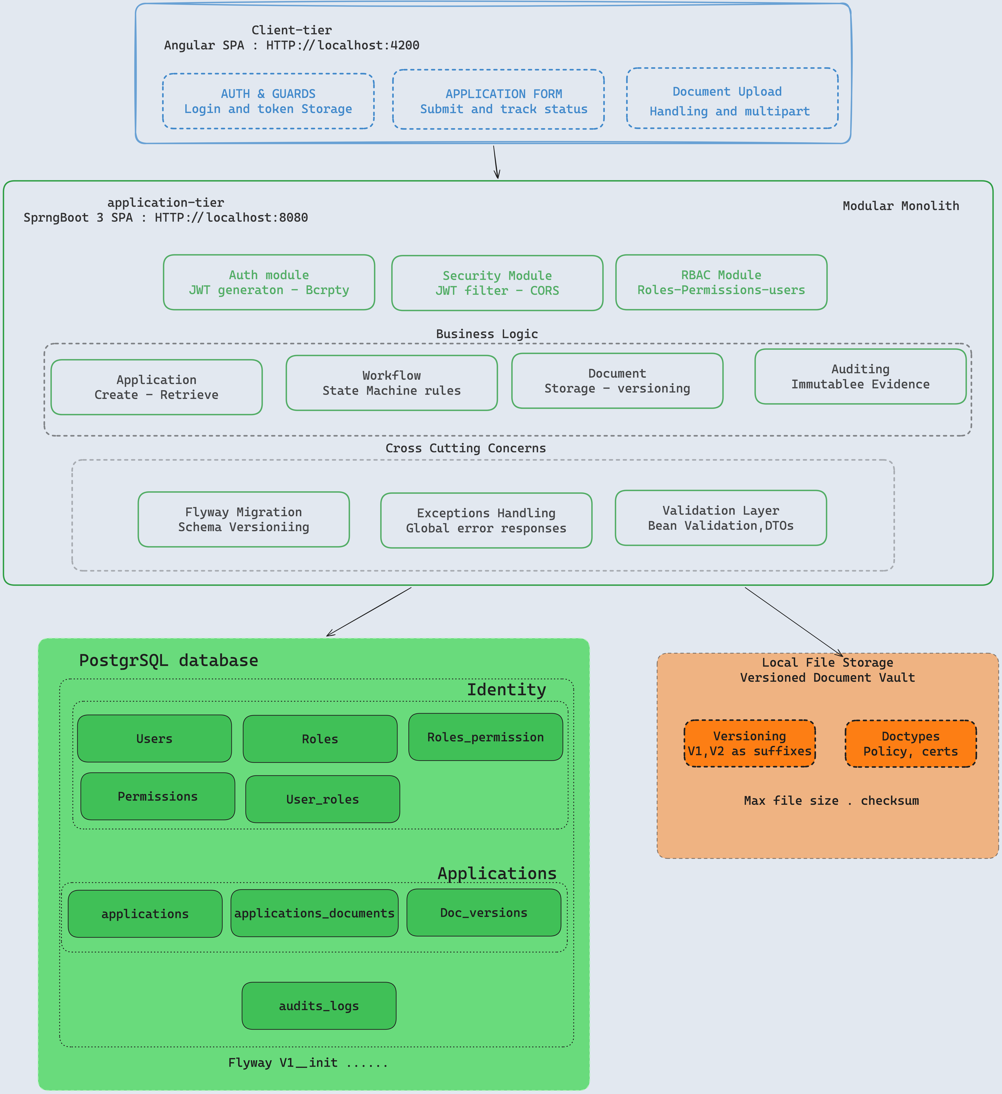

3.2 Why this architecture fits the assessment
- The frontend is kept thin and workflow-aware, but not trusted for enforcement.
- Controllers only expose APIs and delegate business logic to services.
- WorkflowService centralizes state transition rules so the rules do not leak into multiple controllers.
- Audit writes happen in backend transactions, not from frontend-generated events.
- Flyway makes the database reproducible for exam reviewers through versioning.
- Local filesystem storage avoids cloud setup while still demonstrating versioned document handling.

4. Backend Package Structure
com.bnr.backend
auth
controller, dto, jwt, JwtAuthenticationFilter, JwtService, service
users
controller, dto, entity, repository, service
roles
entity, repository
applications
controller, dto, entity, repository, service
workflow
controller, service
documents
controller, dto, entity, repository, service
audit
controller, dto, entity, repository
security
SecurityConfig ,UserPrincipal, CustomUserDetailsService, CurrentUserService
common
dto, enums, util
This structure was selected because it maps directly to business capabilities. Each module owns its own responsibility, which improves readability and makes the codebase easier for another engineer to continue.

5. Frontend Architecture and Integration
The Angular frontend runs on http://localhost:4200 and communicates with the backend API at http://localhost:8080/api. CORS is configured on the backend security config to allow this local port.
Frontend area | Responsibility
Auth service | Calls login API, stores JWT token and user object.
HTTP interceptor | Adds Authorization: Bearer token to protected API calls.
Route guards | Prevent unauthenticated access and enforce role-based navigation.
Application service | Calls create/list/detail workflow endpoints.
Document upload component | Builds FormData with application fields and required files.
Audit UI | Displays backend-generated audit records.

Frontend actions are role-aware for usability, but security is not delegated to the UI. All important permissions and transitions are validated again on the backend.

6. Data Model

6.1 Core tables
Table | Purpose | Important columns
users | Stores users and login identity. | id, email, password, full_name, active, created_at
roles | Business roles. | id, name, description
permissions | Granular capabilities. | id, name, description
role_permissions | Maps permissions to roles. | role_id, permission_id
user_roles | Maps users to roles. | user_id, role_id
applications | Main licensing application. | id, reference_number, institution_name, license_type, business_address, status, submitted_by, reviewer_id, approver_id, version
application_documents | Logical document slot for each required document. | id, application_id, document_type, created_at
application_document_versions | Versioned uploaded file metadata. | id, document_id, version_number, original_filename, stored_filename, file_path, mime_type, file_size, uploaded_by, uploaded_at
audit_logs | Permanent evidence trail. | id, application_id, actor_id, action, previous_state, new_state, timestamp, comment

6.2 Why UUIDs
UUIDs are used for main records because they are safer for public API exposure than sequential identifiers. They reduce predictable enumeration risk and support future distributed generation if the system is split later.

6.3 Why optimistic locking and workload distribution strategy
The system enforces strict backend-controlled access rules where applicants can only view their own applications, reviewers can only access applications assigned to them, approvers can only access applications assigned for approval, and administrators can view all records. This prevents unauthorized access and ensures role isolation at the API level.
To balance operational workload, newly submitted applications are automatically assigned to the reviewer and approver with the fewest currently assigned applications. This improves fairness, reduces bottlenecks, and supports scalable workflow management.
also addresses concurrent update risks using optimistic locking with a version field on the application entity. When two users attempt to modify the same application simultaneously, only the first successful transaction is committed while subsequent outdated updates are rejected with a conflict response. This prevents inconsistent workflow states and guarantees workflow integrity in multi-user scenarios.

7. Workflow State Machine
The workflow is intentionally small and explicit. A limited state machine is easier to verify, test, and explain. All transitions are enforced by the backend WorkflowService.
Current state | Allowed next state | Actor | Endpoint/action
SUBMITTED | UNDER_REVIEW | REVIEWER | POST /api/review/{id}/start
UNDER_REVIEW | REVIEW_COMPLETED | REVIEWER | POST /api/review/{id}/complete
UNDER_REVIEW | INFO_REQUESTED | REVIEWER | POST /api/review/{id}/request-info
INFO_REQUESTED | UNDER_REVIEW | REVIEWER after applicant response | POST /api/review/{id}/start
REVIEW_COMPLETED | APPROVED | APPROVER | POST /api/approval/{id}/approve
REVIEW_COMPLETED | REJECTED | APPROVER | POST /api/approval/{id}/reject

7.1 Workflow rules
- Only listed transitions are allowed.
- APPROVED and REJECTED are terminal states and cannot change.
- The final approver cannot be the same user who reviewed the application.
- Every transition writes an audit log entry.
- Invalid transitions are rejected at API/service level, not only hidden in the UI.

8. RBAC and Security Design

8.1 Authentication
JWT authentication was selected because it is stateless, easy to integrate with Angular, and common for REST APIs. Passwords are hashed using BCrypt, so raw passwords are never stored.

8.2 Authorization
The system uses roles and permissions rather than hard-coded role checks everywhere. This keeps authorization flexible and makes it easier to evolve permissions later below are seed mapping.
Role | Permissions | Reasoning
APPLICANT | CREATE_APPLICATION, VIEW_OWN_APPLICATION | Applicants can submit and follow their own records, but cannot review or decide.
REVIEWER | REVIEW_APPLICATION, REQUEST_INFORMATION, VIEW_ASSIGNED_APPLICATIONS | Reviewers assess applications and ask for more information, but cannot issue final decisions.
APPROVER | APPROVE_APPLICATION, REJECT_APPLICATION | Approvers make final decisions, but cannot be the same person who reviewed.
ADMIN | MANAGE_USERS, VIEW_ALL | Admins manage users and have visibility, but audit records remain protected from modification.

8.3 CORS
CORS allows the local Angular frontend origin http://localhost:4200. This keeps local development and review smooth while avoiding unrestricted origins.

9. Audit Trail and Evidence Strategy
The audit trail is designed as evidence, The backend creates audit entries automatically when workflow transitions happen. This avoids trusting the frontend to report its own actions.
Audit field | Purpose
actor_id | Identifies who performed the action.
application_id | Links the action to the affected application.
action | Records what happened, such as START_REVIEW or APPROVED_APPLICATION.
previous_state | Shows state before action.
new_state | Shows state after action.
timestamp | Records when the event happened.
comment | Stores reviewer or approver explanation.

9.1 Append-only design
- No update or delete endpoint is provided for audit records.
- Audit entries are inserted only by backend services.
- The design supports a database trigger to prevent UPDATE and DELETE on audit_logs table.
- Administrators can manage users but should not be able to alter legal evidence.

10. Document Handling and Versioning
Applicants upload three mandatory supporting documents when submitting an application. The backend validates the files, stores them locally, and stores metadata in PostgreSQL.
Document type | Required (enforced on frontend)
MARKET_RISK_MANAGEMENT_POLICY | Yes
CLIENT_ASSET_PROTECTION_POLICY | Yes
TRADING_POLICY | Yes

10.1 Server-side validation
- Maximum size: 5MB per file.
- Allowed formats: PDF, DOC, DOCX.
- File metadata stored in the database.
- Files stored on local filesystem under uploads directory.

10.2 Versioning
Files are never overwritten. Each upload creates a new version row. This means earlier evidence remains accessible even if an applicant later resubmits corrected documents.

11. Flyway Migration Strategy
Flyway was used because database schema is part of the application and must be version-controlled. This is important in regulated systems because the schema must be reproducible and reviewable.
- Migrations create and evolve schema deterministically.
- Reviewers can run the application without manually creating tables.
- Executed migrations should not be edited; new changes are added as new migration files.
- This avoids environment drift between machines.

12. Hard Decisions and Trade-offs
Decision | Reason | Trade-off | What I would add later
Modular monolith | Fits transactional workflow and audit consistency. | Less independent deployability than microservices. | Extract services only after real scale pressure.
No Docker dependency | Avoids evaluator friction and speeds local review. | Requires local Java/PostgreSQL/Node setup. | Add docker-compose for fully reproducible environments.
Local filesystem storage | Meets no-cloud requirement and is simple to review. | Not ideal for multi-node production. | Use S3, Azure Blob, or RusFS.
JWT | Stateless API and clean Angular integration. | Needs token expiry and careful storage. | Add refresh tokens and revocation.
Backend state machine | Prevents bypassing frontend controls. | Requires careful service tests. | Add formal workflow policy tests.
Flyway | Reproducible schema and enterprise migration discipline. | Cannot edit applied migrations. | Add CI migration validation.

13. Reviewer Run Guide

13.1 Prerequisites
- Java 21
- PostgreSQL 16
- Node.js and npm
- Angular CLI

13.2 Backend setup
CREATE DATABASE bnr_exam;
cd backend
./mvnw spring-boot:run
Backend runs at http://localhost:8080.
Scalar API documentation is available at http://localhost:8080/scalar.

13.3 Frontend setup
cd frontend
npm install
ng serve
Frontend runs at http://localhost:4200.

13.4 Default users
Role | Email | Password
ADMIN | admin@bnr.rw | admin123
APPLICANT | applicant@bnr.rw | applicant123
REVIEWER | reviewer@bnr.rw | reviewer123
APPROVER | approver@bnr.rw | approver123

13.5 End-to-end test flow
1. Login as applicant.
2. Submit an application with all three required documents.
3. Confirm status is SUBMITTED.
4. Login as reviewer.
5. Start review and confirm status is UNDER_REVIEW.
6. Complete review and confirm status is REVIEW_COMPLETED.
7. Login as approver.
8. Approve or reject the application.
9. Confirm final decision cannot be changed.
10. View audit trail and confirm all actions were recorded.
11. View document metadata and confirm uploaded files are listed with versions.

14. What Would Be Added with More Time
- Unit tests for every valid and invalid workflow transition.
- Authorization tests proving every role can and cannot perform expected actions.
- Refresh token flow, token revocation, and shorter access-token lifetime.
- Cloud object storage and antivirus scanning for uploaded documents.
- CI/CD pipeline (sonar, owasp, …etc.) running backend tests, frontend tests, and Flyway validation.
- Compliance reporting dashboard and exportable audit reports.
- Create vault to store app secret for better security

